**PHASE 5 - PROJECT DOCUMENT**

|  |  |
| --- | --- |
| PROJECT TITLE 9238 | SENTIMENT ANALYSIS FOR MARKETING |
| NAME | **BALA SANGEETHA C** |
| TEAM ID | **5277** |
| TEAM NAME | **Proj_204223_Team_1** |
| COLLEGE CODE- NAME | **9238 - MANGAYARKARASI COLLEGE OF ENGINEERING PARAVAI , MADURAI** |
| GROUP | **5** |
| GITHUB REPOSITORY LINK | **https://github.com/balasangeetha56/IBM-NaanMudhalvan-AI.git** |

**1. Project Definition :**

**1.1 Project Overview:**

Sentiment Analysis involves classifying a text into various sentiments, such as positive or negative, Happy, Sad or Neutral, also the sentiment or emotional tone expressed in textual data, such as customer reviews, social media posts, survey responses, and more. Here's an overview of sentiment analysis for marketing:

**2. Problem Statement :**

A problem statement for sentiment analysis in marketing should be clear and concise, outlining the specific challenge or objective you want to address using sentiment analysis techniques. Here's an example of a problem statement for sentiment analysis in marketing.

**3. Abstract :**

Sentiment analysis has emerged as a powerful tool in the field of marketing, enabling businesses to gain valuable insights into consumer perceptions and emotions. In today's digital age, where social media and online reviews play a pivotal role in shaping brand reputation, understanding and harnessing sentiment has become essential. This study explores the application of sentiment analysis techniques to analyze consumer sentiment towards products, services, and brands. We delve into the methodologies, tools, and data sources commonly used in sentiment analysis for marketing purposes. Furthermore, we discuss the challenges and ethical considerations associated with sentiment analysis in this context. Ultimately, this research highlights the significance of sentiment analysis as a strategic tool for marketing professionals, offering the potential to enhance customer engagement, improve brand perception, and drive business growth.

**4. Design Thinking Process :**

Design thinking is a human-centered problem-solving approach that can be applied to sentiment analysis in marketing to gain a deeper understanding of customer perceptions and emotions. Here's a step-by-step design thinking process tailored for sentiment analysis in marketing:

**4.1. Empathize:**

* Start by understanding the target audience, their pain points, and the sources of data where sentiment is expressed, such as social media, reviews, and customer feedback.
* Conduct interviews and surveys to gather insights about customer sentiment and preferences.

**4.2. Define:**

* Clearly define the problem or challenge you want to address through sentiment analysis in the context of marketing. This might include improving customer satisfaction, identifying product strengths and weaknesses, or evaluating the impact of marketing campaigns.
* Develop specific goals and metrics to measure the success of your sentiment analysis efforts.

**4.3. Ideate:**

* Brainstorm potential approaches and solutions for sentiment analysis. Consider both the technical aspects (tools and methods) and the strategic aspects (how to apply the insights in marketing).
* Encourage creativity and out-of-the-box thinking to generate innovative ideas.

**4.4. Prototype:**

* Create prototypes of sentiment analysis models or tools. This might involve developing machine learning models, sentiment lexicons, or rule-based systems.
* Develop data preprocessing pipelines to clean and prepare the text data for analysis.
* Implement visualization techniques to effectively present sentiment insights.

**4.5. Test:**

* Test the sentiment analysis prototypes with a subset of the data to ensure they are accurate and align with the defined problem and goals.
* Seek feedback from relevant stakeholders and iterate on the prototypes based on their input.

**4.6. Implement:**

* Deploy the sentiment analysis solution at scale to analyze a broader dataset in real time.
* Use the insights gained to inform marketing strategies, product improvements, and customer engagement efforts.
* Continuously monitor the sentiment trends and adapt marketing approaches as needed.

**4.7. Feedback and Refinement:**

* Establish a feedback loop that allows for ongoing refinement and improvement of the sentiment analysis process.
* Regularly review and adjust your approach based on the changing landscape of customer sentiment and marketing needs.

By applying this design thinking process to sentiment analysis in marketing, you can better align your strategies with customer sentiment and preferences, leading to improved customer satisfaction and more effective marketing campaigns.

**5. Phases Of Development**

Sentiment analysis for marketing involves the process of analyzing and understanding the sentiments and opinions expressed by customers or the general public about a product, brand, or a specific marketing campaign. Here are the typical phases of development for sentiment analysis in the context of marketing:

**5.1. Problem Definition and Goal Setting:**

* Define the specific marketing problem or goals you want to address with sentiment analysis. For example, you might want to understand customer reactions to a new product launch or assess brand sentiment over time.

**5.2. Data Collection:**

Gather relevant data sources, which can include social media posts, customer reviews, surveys, and any other customer feedback channels.

**5.3. Data Preprocessing:**

* Clean and preprocess the data to remove noise, such as irrelevant information, special characters, and URLs.
* Tokenize and normalize the text (e.g., converting to lowercase).
* Remove stop words and perform stemming or lemmatization.

**5.4. Data Labeling and Annotation:**

* Annotate the data with sentiment labels (e.g., positive, negative, neutral) manually or by using pre-existing sentiment analysis datasets.
* Consider using crowd-sourced platforms or machine learning models for automated labeling.

**5.5. Feature Engineering:**

* Extract relevant features from the text data, such as TF-IDF (Term Frequency-Inverse Document Frequency), word embeddings (Word2Vec, GloVe), or BERT embeddings.

**5.6. Model Selection:**

* Choose an appropriate sentiment analysis model. Common options include rule-based models, traditional machine learning algorithms (Naive Bayes, SVM), and deep learning models (LSTM, CNN, BERT).

**5.7. Model Training and Tuning:**

* Train the selected model on your annotated dataset.
* Fine-tune hyperparameters to optimize model performance.

**5.8. Evaluation:**

* Assess the performance of the sentiment analysis model using relevant evaluation metrics (accuracy, F1-score, precision, recall) and consider using cross-validation techniques to ensure generalization.

**5.9. Deployment:**

* Integrate the sentiment analysis model into your marketing pipeline or tool. This can include real-time analysis of social media posts or batch processing of customer feedback.

**5.10. Monitoring and Maintenance:**

* Continuously monitor the performance of the sentiment analysis system and retrain the model as needed.
* Stay updated with changes in customer sentiment and adapt your marketing strategies accordingly.

**5.11. Insights and Reporting:**

* Translate the sentiment analysis results into actionable insights for marketing teams.

- Generate reports and visualizations to communicate the findings effectively.

**5.12. Iterative Improvement:**

* Continuously iterate on the sentiment analysis process by incorporating feedback from marketing campaigns and making improvements to the system as needed.

**5.13. Integration with Marketing Strategy:**

* Incorporate the sentiment analysis findings into your marketing strategy to make informed decisions about product development, branding, and customer engagement.

Remember that the effectiveness of sentiment analysis in marketing relies on the quality of data, the choice of the right model, and the ability to turn insights into actionable strategies. It's an ongoing process that requires adaptability and responsiveness to changing market conditions and customer sentiment.

**6. Data set used**

A dataset plays a crucial role in sentiment analysis for marketing. It serves as the foundation for building and training machine learning or natural language processing models to analyze customer sentiment. Here's how a dataset is used in sentiment analysis for marketing.

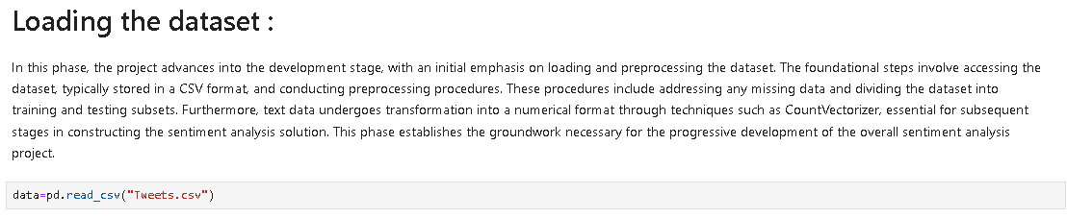

**6.1. Data Collection:**

* Datasets are collected from various sources that contain customer feedback relevant to the marketing goals. These sources can include social media posts, customer reviews, surveys, emails, chat transcripts, or any other text-based communication channels.

**6.2. Data Preprocessing:**

* The collected data is preprocessed to prepare it for analysis. This involves tasks like removing noise, special characters, URLs, and irrelevant information. Text is also tokenized and normalized (e.g., converting to lowercase) for consistency.

**6.3. Data Labeling:**

* Datasets need to be labeled with sentiment labels (e.g., positive, negative, neutral) to serve as the ground truth for model training and evaluation. This labeling can be done manually by human annotators or through automated methods.

**6.4. Feature Extraction:**

* Features are extracted from the text data. This step includes converting the text into numerical representations that machine learning models can work with. Common feature extraction techniques include TF-IDF, word embeddings (Word2Vec, GloVe), or contextual embeddings (BERT).

**6.5. Model Training:**

* Datasets, along with their corresponding labels, are used to train machine learning or deep learning models. Various models can be used, such as Naive Bayes, Support Vector Machines (SVM), recurrent neural networks (RNNs), convolutional neural networks (CNNs), or transformer-based models like BERT.

**6.6. Model Evaluation:**

* The performance of the sentiment analysis model is evaluated using metrics like accuracy, F1-score, precision, and recall. The dataset is often split into training, validation, and test sets to assess how well the model generalizes to new data.

**6.7. Model Deployment:**

* After the model is trained and evaluated, it can be deployed to perform sentiment analysis on new, incoming data. For marketing, this may involve analyzing customer sentiment in real-time or processing batches of customer feedback.

**6.8. Monitoring and Maintenance:**

* The dataset is used for ongoing monitoring of the sentiment analysis system. If the model's performance degrades or if new trends emerge in customer sentiment, the dataset may need to be updated and the model retrained.

**6.9. Insights and Reporting:**

* The analysis of the sentiment dataset generates insights that are valuable for marketing teams. These insights can be used to make informed decisions, track the success of marketing campaigns, and adjust strategies.

**6.10. Iterative Improvement:**

* Over time, as more data becomes available and marketing strategies evolve, the dataset and the sentiment analysis process may need to be refined and improved.

In summary, a dataset serves as the training data for sentiment analysis models used in marketing. The quality and relevance of the dataset are critical to the success of sentiment analysis, as they influence the accuracy and effectiveness of the analysis in shaping marketing strategies and decisions. Additionally, the dataset should be regularly updated to reflect changes in customer sentiment and market dynamics.

**7. Data Preprocessing**

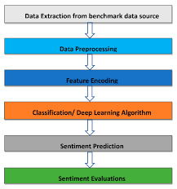

Data preprocessing is a critical step in sentiment analysis for marketing, as it helps clean and prepare the data for analysis. Here are some essential data preprocessing steps:

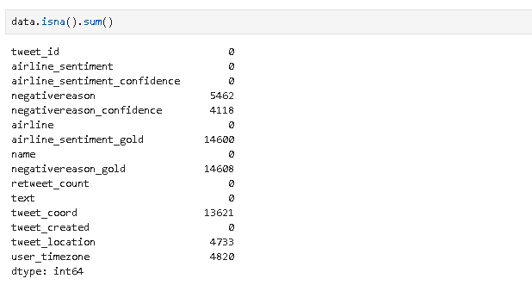

**7.1. Data Collection:**

Gather relevant data from various sources, such as social media, customer reviews, surveys, or other customer feedback channels.

**7.2. Data Cleaning:**

* **Remove Noise:** Eliminate irrelevant characters, symbols, or special characters that don't contribute to sentiment analysis.
* **Handle Missing Data:** Deal with missing values by imputing, removing, or replacing them.

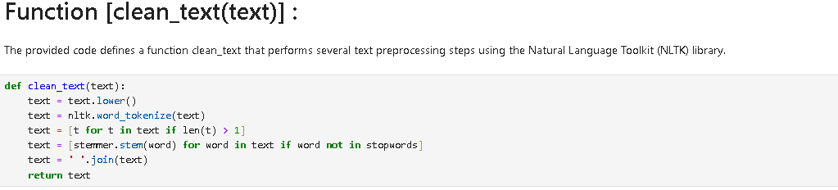

**7.3. Text Tokenization:**

* **Sentence Tokenization:** Split the text into individual sentences.
* **Word Tokenization:** Split each sentence into words or tokens.

**7.4. Text Lowercasing:**

Convert all text to lowercase to ensure consistency and prevent case sensitivity issues.

**7.5. Stop Word Removal:**

Remove common stopwords (e.g., "and," "the," "in") that do not carry sentiment information. This can help reduce dimensionality.

**7.6. Stemming or Lemmatization:**

* **Stemming:** Reduce words to their root form (e.g., "running" to "run").
* **Lemmatization:** Reduce words to their base or dictionary form (e.g., "better" to "good").

**7.7. Removing HTML Tags and URLs:**

* If the data contains HTML tags or URLs, remove them, as they are often irrelevant for sentiment analysis.

**7.8. Handling Emoticons and Emoji:**

* Depending on your specific use case, you may need to convert emoticons and emojis to textual representations or remove them.

**7.9. Handling Special Characters:**

* Deal with special characters or symbols appropriately. You may choose to remove, replace, or convert them.

**7.10. Spell Checking and Correction:**

* Correct common spelling mistakes, which can improve the accuracy of sentiment analysis.

**7.11. Feature Selection:**

* Select relevant features or keywords from the text data, especially if you're working with limited resources or want to focus on specific aspects.

**7.12. Data Labeling:**

* Assign labels to your data, such as positive, negative, or neutral sentiments, based on your specific criteria.
* Ensure consistent and accurate labeling of the dataset.

**7.13. Balancing the Dataset:**

* If your dataset is imbalanced (e.g., more positive reviews than negative ones), consider techniques like oversampling or undersampling to create a balanced dataset.

**7.14. Data Splitting:**

* Divide your dataset into training, validation, and testing sets to evaluate the performance of your sentiment analysis model.

**7.15. Vectorization:**

* Convert text data into numerical format using techniques like TF-IDF (Term Frequency-Inverse Document Frequency) or word embeddings (e.g., Word2Vec or GloVe).
* Consider using pre-trained word embeddings to capture semantic information.

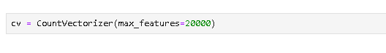

**7.16. Data Scaling or Normalization:**

* If you are using numerical features alongside text data, normalize or scale them to ensure that they have similar magnitudes.

**7.17. Feature Engineering:**

* Create additional features that may help improve sentiment analysis, such as sentiment lexicons, sentiment scores, or domain-specific features.

**7.18. Encoding Labels:**

* If your labels are not in numerical format, encode them into numeric values (e.g., 0 for negative, 1 for neutral, 2 for positive).

**7.19. Data Transformation:**

* Depending on your choice of machine learning algorithm, you may need to transform the data into a format suitable for the model (e.g., one-hot encoding for categorical variables).

**7.20. Data Preprocessing Pipeline:**

* Create a data preprocessing pipeline to automate these steps, ensuring consistency and reproducibility.
* Remember that the specific steps and techniques you use may vary based on your dataset, project requirements, and the tools and libraries you are working with. It's essential to experiment and fine-tune the preprocessing steps to achieve the best results for your marketing sentiment analysis project.

**8. Features Extraction Techniques**

Naive Bayes is a probabilistic classifier used in sentiment analysis. It's primarily used for classification, so you'll typically represent text data as feature vectors, and then use Naive Bayes to classify those feature vectors into sentiment classes. Here are some feature extraction techniques for sentiment analysis with formulas using Naive Bayes:

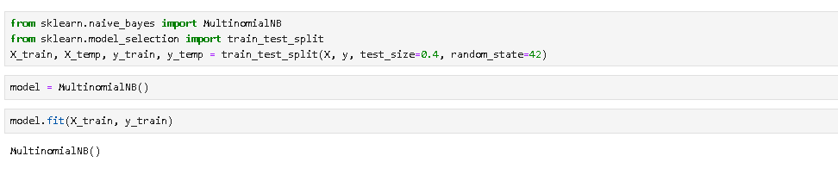

**8.1. Bag of Words (BoW):**

**Formula:** Create a feature vector for each document, where each feature represents the count of each term in a predefined vocabulary.

BoW_feature(word_i) = Count of word_i in D

**8.2. Term Frequency-Inverse Document Frequency (TF-IDF):**

**Formula**: Compute the TF-IDF score for each word in a document.

```

TF-IDF(word_i, D) = (Term Frequency of word_i in D) * (Inverse Document Frequency of word_i)

**Term Frequency (TF) = (Number of times word_i appears in D) / (Total number of words in D)**

* Inverse Document Frequency (IDF) = log((Total number of documents) / (Number of documents containing word_i))

**8.3. N-grams:**

**Formula:** Create feature vectors based on the presence or count of n-grams in the document.

``

N-grams_feature(n-gram_i) = Presence or Count of n-gram_i in D

```

**8.4. Word Embeddings:**

Word_embedding_vector(word_i) = Pre-trained vector for word_i

**8.5. Sentiment Scores**:

**Formula**: Compute a sentiment score for the entire document using sentiment analysis tools or libraries.

Sentiment_score(D) = Sentiment score assigned to D by the sentiment analysis tool

In a Naive Bayes classifier, the probability of a document belonging to a particular sentiment class is calculated based on these features. The formula for calculating the class probability (P(classfeatures)) using the Naive Bayes algorithm is as follows:

P(class | features) = P(class) * ∏(P(feature_i | class))

* P (class): Prior probability of the class.
* P ( feature_i | class): Probability of feature i given the class. This is typically estimated based on the training data using counts or other probability models.
* Once the class probabilities are computed for each sentiment class, the class with the highest probability is assigned as the predicted sentiment for the document.
* Please note that Naive Bayes assumes that the features (words, n-grams, etc.) are conditionally independent, which is often an oversimplification for text data. However, Naive Bayes can still work reasonably well for sentiment analysis tasks, especially when you have a good representation of text data in feature vectors.

**9. Model training for sentiment analysis for marketing**

Training a sentiment analysis model for marketing involves steps

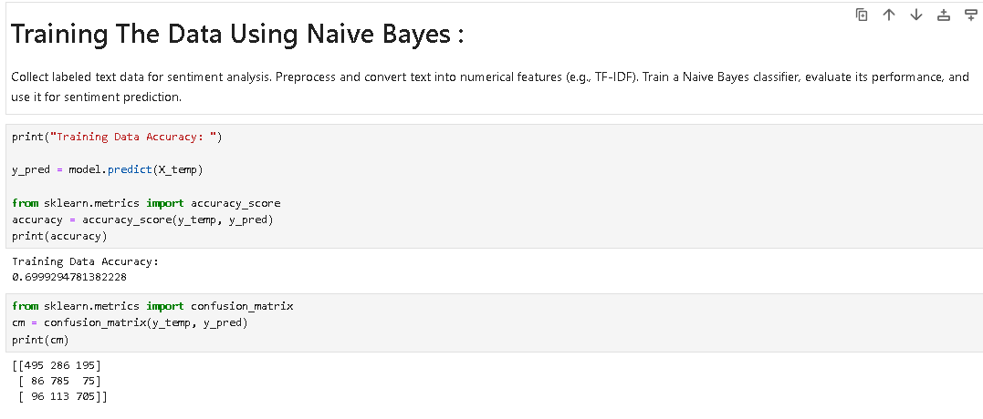

**9.1. Data Collection:**

* Gather a labeled dataset of text data, which can be customer reviews, social media comments, or any text related to your marketing efforts. Ensure that the data includes sentiment labels (positive, negative, neutral).

## **9.2. Data Preprocessing:**

## Clean the text data by removing special characters, punctuation, and irrelevant information. Tokenize the text into words or subword units (e.g., using word embeddings or subword tokenizers like Byte-Pair Encoding).

## **9.3. Feature Extraction:**

* Convert the text data into numerical features. You can use techniques like TF-IDF (Term Frequency-Inverse Document Frequency) or word embeddings (e.g., Word2Vec, GloVe) to represent words or phrases as numerical vectors.

## **9.4. Model Selection:**

## Choose a suitable machine learning or deep learning model for sentiment analysis. Common choices include logistic regression, Naïve Bayes, support vector machines, or recurrent neural networks (RNNs) and transformers like BERT for deep learning.

## **9.5. Model Training:**

## Train the selected model on your labeled dataset. Fine-tune pre-trained models like BERT on your specific marketing data if applicable.

## **9.6. Hyperparameter Tuning:**

## Optimize hyperparameters like learning rates, batch sizes, and the architecture of the model to improve performance.

## **9.7. Evaluation:**

## Use metrics such as accuracy, F1-score, or area under the ROC curve to assess the model's performance. Cross-validation can help ensure robustness.

## **9.8. Iterative Refinement:**

## Based on the evaluation results, refine the model by adjusting parameters, incorporating more data, or employing data augmentation techniques.

## **9.9. Deployment:**

## Deploy the trained model to your marketing systems, whether it's for real-time sentiment analysis of social media posts or analyzing customer feedback.

## **9.10. Monitoring and Maintenance:**

## Continuously monitor the model's performance and retrain it periodically with fresh data to adapt to evolving trends and language changes.

## **9.11. Feedback Loop:**

## Collect feedback from marketing analysts and end-users to improve the model over time.

## Remember that sentiment analysis models should be specific to the context of your marketing efforts and may require customization for optimal results. Additionally, ethical considerations, like bias and privacy, should be taken into account throughout the process.

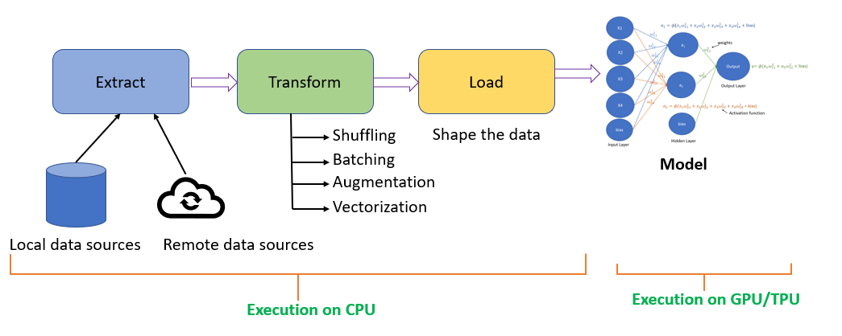

**10. Evaluation metrics for sentiment analysis for marketing**

When evaluating a sentiment analysis model for marketing, you can use various metrics to assess its performance. Here are some common evaluation metrics:

**10.1 .Accuracy:**

* It measures the proportion of correctly classified instances. However, accuracy may not be the best metric if the classes are imbalanced.

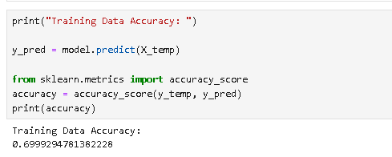

**10.2. Precision:**

* Precision is the ratio of true positive predictions to the total positive predictions. It measures the model's ability to correctly identify positive sentiment without making too many false positive predictions.

**10.3. Recall:**

* Recall (Sensitivity) is the ratio of true positive predictions to the actual positive instances. It measures how well the model captures all positive sentiment examples.

**10.4. F1-Score:**

* The F1-score is the harmonic mean of precision and recall. It provides a balance between precision and recall, which can be useful when the dataset is imbalanced.

**10.5. Area Under the ROC Curve (AUC-ROC):**

* This metric is often used in binary sentiment analysis. It evaluates the model's ability to distinguish between positive and negative sentiments. A higher AUC-ROC indicates better performance.

**10.6. Confusion Matrix:**

* A confusion matrix provides a detailed breakdown of true positives, true negatives, false positives, and false negatives. It's valuable for understanding where the model makes errors.

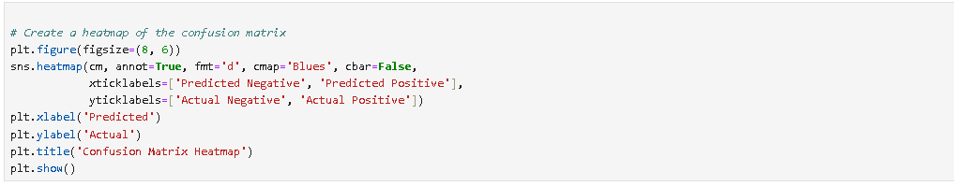

OUTCOME :

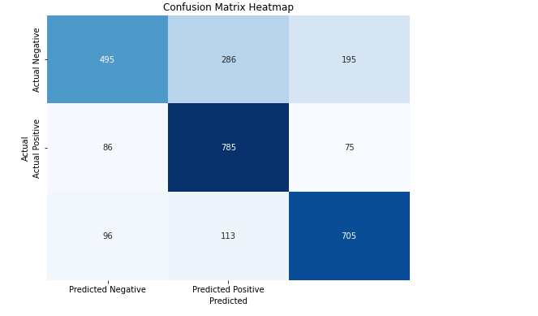

**10.7. Root Mean Squared Error (RMSE):**

* Similar to MAE, RMSE is used in regression-based sentiment analysis and provides a measure of the model's predictive accuracy. It penalizes large errors more than MAE.

**10.8. Cohen's Kappa:**

* Kappa measures the agreement between the model's predictions and the actual labels while considering the possibility of chance agreement. It's useful when dealing with imbalanced datasets.

**10.9. Classification Report:**

* A classification report provides a summary of various evaluation metrics (precision, recall, F1-score) for both positive and negative sentiments.

**Custom Metrics:**

* Depending on your specific marketing goals, you might define custom evaluation metrics, such as sentiment intensity scores or sentiment distribution analysis.

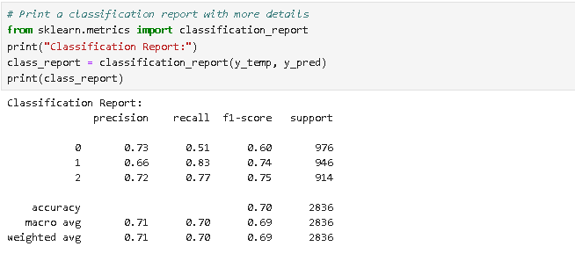

**EVALUATION:**

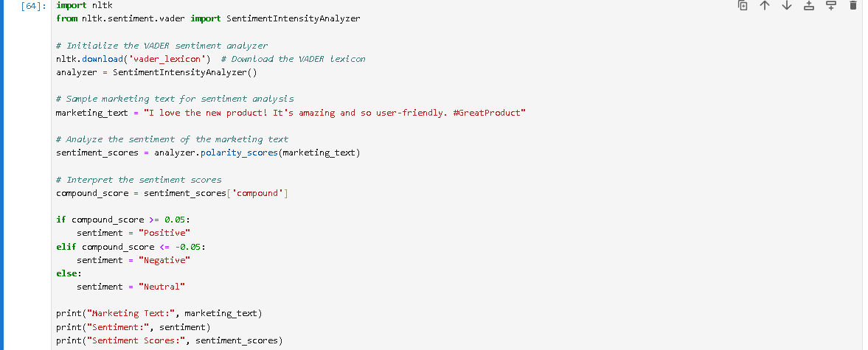

**OUTCOME :**

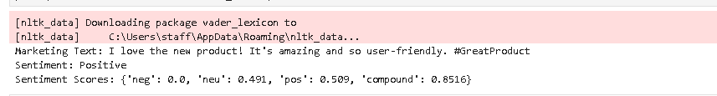

**CONCLUSION :**

Sentiment analysis is a vital component of modern marketing strategies, enabling businesses to tap into the emotions and preferences of their customers. By extracting insights from customer sentiment, companies can refine their campaigns, optimize products, and build stronger customer relationships. It provides a competitive edge, crisis management capabilities, and real-time responsiveness, enhancing the overall effectiveness of marketing efforts. In today's digital age, sentiment analysis is a powerful tool that can drive brand success and customer engagement to new heights.